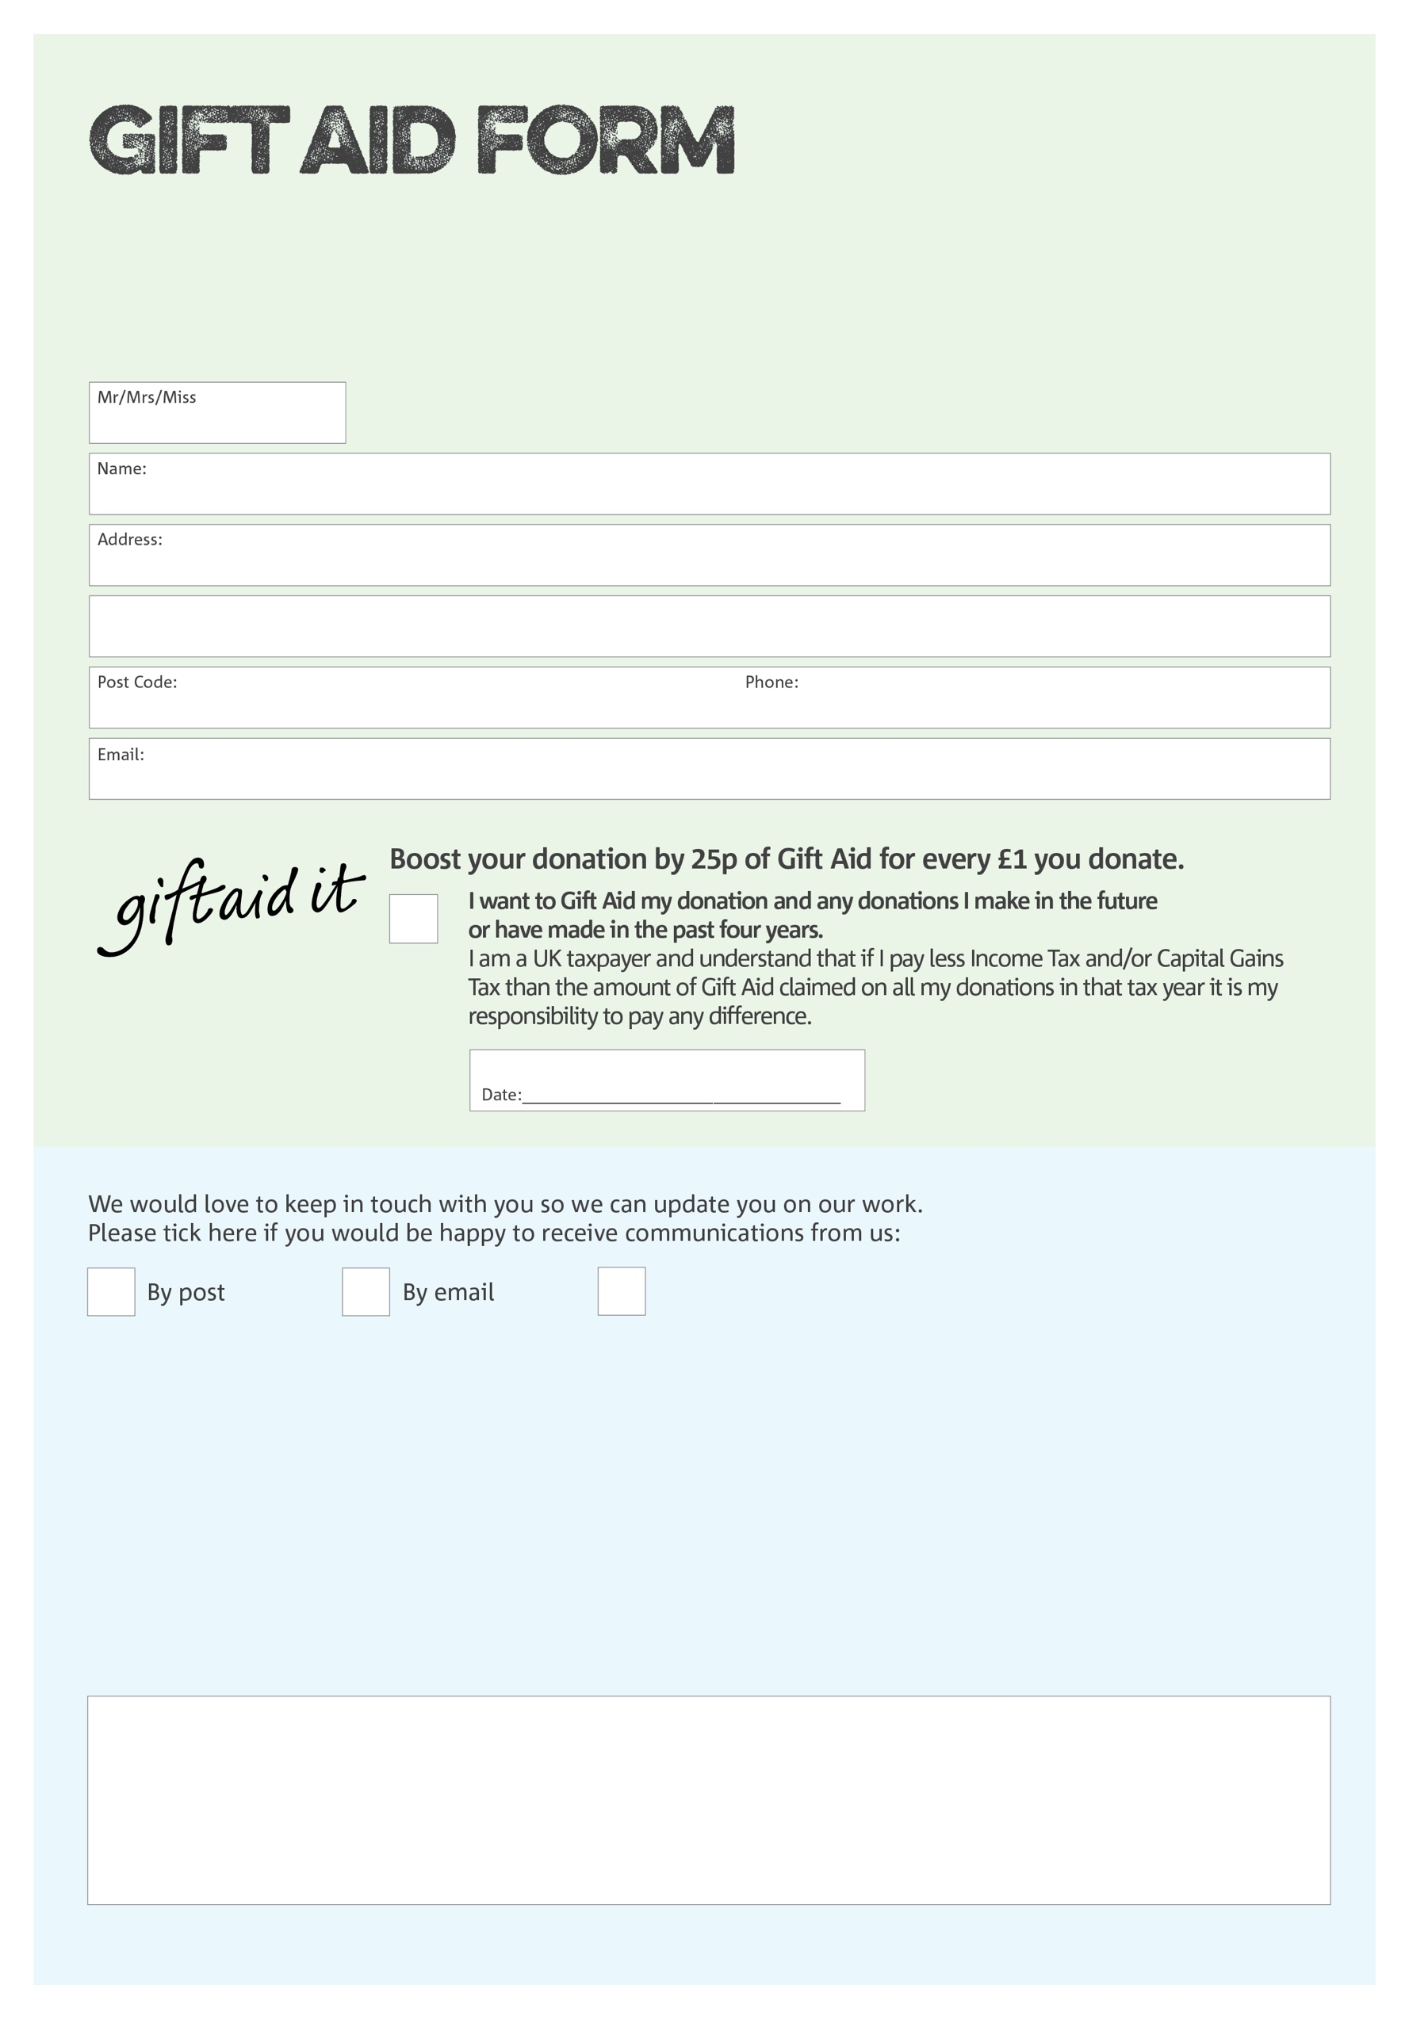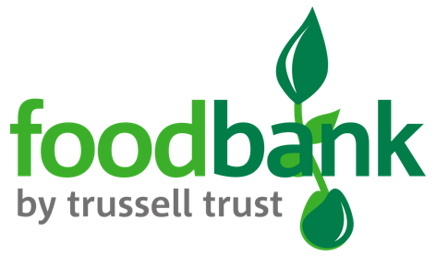

By filling in this form Oswestry and Borders Foodbank will receive an extra 25p for every £1 you give at no extra cost to you. Thank you!

**Data protection**

*'Oswestry and Borders Foodbank is committed to protecting your privacy and will process your personal data in accordance with current Data Protection legislation. Oswestry and Borders Foodbank collects information to keep in touch with you and supply you with information relating to our work. To unsubscribe from our newsletter, send a message to the email address above with the word unsubscribe in the subject line. A full data privacy statement for financial donors is available from the foodbank on request.’*

You can change your preferences any time by contacting us on 01691 671940 or emailing us at

info@oswestryandborders.foodbank.org.uk

I do not wish to receive future communications from Oswestry and Borders Foodbank

We would love to know why you have chosen to donate to Oswestry and Borders Foodbank. If you would like to share your motivation let us know below:

Charity Number 1143519. Registered in England and Wales